

EURASNET Website Proposal

Introduction

SCRI, Dundee has been asked by the management of the European Alternative Splicing Network of Excellence (EURASNET) to take over responsibility for the EURASNET website. The advantages of this function being hosted at SCRI are 1) SCRI has a strong Communications and IT infrastructure to establish and support the website, 2) John Brown leads the Workpackage (WP21) on outreach to the RNA community, 3) John Brown has excellent interactions with Andrea Barta who leads the Public Understanding of Science Workpackage (WP19), and 4) the group of Angus Lamond is also located in Dundee. The intention is therefore to establish the website on a strong basis of interaction among EURASNET groups.

Editorial proposal

The EURASNET website will:

State that EURASNET is a focal point for alternative splicing research in Europe as part of a world-wide community

Publicise and raise awareness of the importance of alternative splicing and how it impacts human health and disease

Provide information about
the Network and how it is organised
the research of the Network
the activities of the Network
the successes of the Network

Provide information on alternative splicing and its link to human disease to
scientists,
clinicians,
the general public,
university teachers
school teachers

Act as a repository of information on shared resources
Requirements

The requirements of EURASNET for an overhauled website with regular and improved information content to meet the objectives of the Network as described in Annex 1 can be met by the following objectives:

- develop a new design for the website,
- incorporate a full Content Management System (CMS),
- CMS to have capability for interactive use by all or selected members of EURASNET with a built-in approval system,
- automatic e-mail alerts/newsletter to members when new information is mounted (will increase use by network Members),
- overhaul the organisation of the public website and Member’s only area,
- searchable website.
- single-click access points for targeted user groups (scientists, clinicians, general public),
- organisation of information gathering from EURASNET members (in association with the Public Understanding of Science function – Claudia Panuschka - Vienna),
- mount and update information on a regular basis,
- provide technical expertise to maintain and update the technical capabilities of the website,
- searchable databases of resources in Member’s only area
- EURASNET blog – noticeboard in Member’s only area where comments, questions, notes can be posted and members can respond
- Events calendar (public and private)

Management of the Website
The management structure to ensure that the EURASNET website is successfully managed in terms of content, design, development and maintenance is:

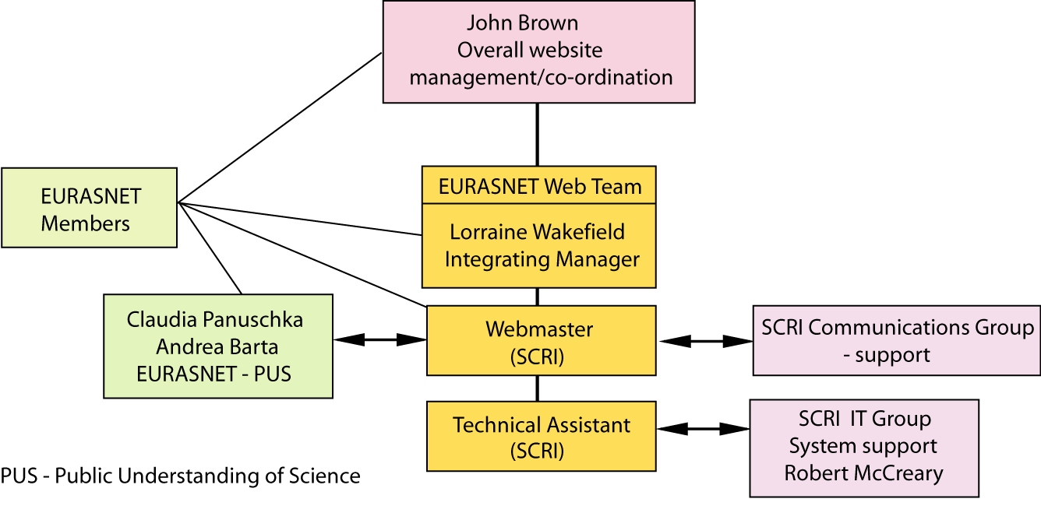

John Brown – to oversee all EURASNET website activities and development at SCRI.

Integrating Manager (Lorraine Wakefield) – Lorraine Wakefield is SCRI’s Online and Information Services Officer and oversees and manages the day-to-day running of the SCRI website. She would take the same project management responsibility for the EURASNET website (20% of her time).

‘EURASNET webmaster’ (Dominika Lewandowska) will be employed on a part-time basis (40%) for three years and two months. She is currently a part-time postdoctoral scientist (60%) working on the EURASNET project. As such she is a molecular biologist with experience in splicing and alternative splicing with an interest in computing. Her role as webmaster will be managed by John Brown and Lorraine Wakefield (SCRI’s Online and Information Services Officer). The primary responsibilities of this role is to ensure that the website content is up-to-date, correct and accessible; to liaise with Claudia Panuschka, Public Science Office (Vienna) to prepare content targeted at key user groups and to regularly contact EURASNET members both with information and with requests for information (news, publications, meetings, job adverts etc.). The webmaster will also be the first line in highlighting any defects/enhancements to the website and working with SCRI IT to deliver the software to rectify them.

Claudia Panuschka – EURASNET Public Understanding of Science Officer (based in Vienna). She will liaise closely with the Webmaster to gather and provide information and prepare scientific content.

Technical Assistant (part-time – 50%) Responsible for technical computing side of the website and liaison with SCRI IT on hardware/software, routine maintenance and trouble-shooting.

Short-term Contracted Website developer – The design and development of the initial release of the EURASNET website is best achieved by a professional website developer. This is the most cost-effective way to generate initial designs for the website and to develop the system. The website development phase will be under the management of Robert McCreary (SCRI IT services) who will ensure adherence to the specification and computing best practices (20% of time from October to December 2007) and oversee the IT interface for the remainder of the contract (10%) of time.

Continual updates/meetings – regular meetings to discuss progress, problems, new developments etc will be held with John Brown and the web team.

Release Strategy

The launch of the new EURASNET website will be in March 2008:

 | Oct07 | Nov07 | Dec07 | Jan08 | Feb08 | Mar08

Information architecture ¹
Define

Standards and processes ²
Document requirements and sign off
Design
Design mock-ups

Template decision
Content
Editorial proposition
Prepare new content

Migrate content

Technology
Define

Code templates and requirements
Test and launch

Staffing
Recruit
Train as required

¹ Information Architecture – analysis of the information currently on the existing EURASNET website; strengths and weaknesses in the existing website; best way to present information to target audiences; recommendations on how to progress a refined website development. (see Annex I for example)

² Design Brief and Outline Specification / Requirements Analysis – along with the design of the website, definition of necessary requirements of the website will be made. This will have to be agreed and signed off by the EURASNET management and designer before development. Initial design mock-ups – exploration of potential designs will be circulated to EURASNET management for agreement.

Budget and justification

 | % time | Jul-Dec 2007 | 2008 | 2009 | 2010 | Total
Staff |  | £ | £ | £ | £ | £
Co-ordinator  (John Brown) | 5% | 1,969 | 4,099 | 4,267 | 4,442 | 14,777
IM (Lorraine  Wakefield) | 20%  (Oct-Dec07 and 08-10) | 1,902 | 7,918 | 8,238 | 8,572 | 26,630
Webmaster (Dominika Lewandowska) | 40% | 0 | 15,835 | 16,477 | 17,143 | 49,455
Technical Assistant | 50% | 0 | 13,488 | 14,037 | 14,609 | 42,134
IT set-up (Robert McCreary) | 20%  (Oct-Dec07)  10%  08-10 | 1,902 | 3,959 | 4,119 | 4,286 | 14,266
Technical
Initial design/  Development ¹ |  | 14,000 | 0 | 0 | 3,000 | 17,000
Hardware ² |  | 7,000 | 0 | 0 | 0 | 7,000
Software ³ |  | 3,000 | 0 | 0 | 0 | 3,000
Consumables ⁴ |  | 0 | 700 | 700 | 700 | 2,100
Training |  | 0 | 700 | 0 | 0 | 700
Travel ⁵ |  | 0 | 500 | 500 | 500 | 1,500
Overheads |  | 6,755 | 9,440 | 9,668 | 10,650 | 36,513
Total |  | 36,528 | 56,639 | 58,006 | 60,902 | £215,074
Total Euros |  |  |  |  |  | €308,979
All salaries include superannuation and national insurance.
¹ Initial design/development phase: There will be initial development of a revised EURASNET website. Design and development will be out-sourced due to the difficultly of locally hiring someone for the relatively short period of time required (three months) who has the necessary skills and experience in delivering high-specification CMS websites. This is our usual and recommended practice and we have a developer who has reliably worked in the past on website projects at SCRI. Further enhancement of the website will be carried out in 2010.
² Dedicated server for website and PCs (incl. VAT).
³ Software requirements of the website (including licences and VAT).
⁴ Back-up tapes and archive.
⁵ Meetings between IM, Webmaster and PUS officer.
Annex I – Example of information architecture - potential site map

Having been pointed in the direction of the Epigenome Network of Excellence website and with the experiences of recently setting up the new SCRI website, we would suggest a EURASNET Home page with:

Home page
EURASNET Network
Upcoming events
Alternative Splicing
What is alternative splicing?
…for biologists
…for clinicians
…for the general public
Alternative splicing and disease
Available technologies
Exon arrays
RT-PCR
Gene therapy approaches
Links to EURASNET publications (e.g. pamphlet)
List of sub-directories

List of Subdirectories

Home
About Us
EURASNET network
Alternative splicing Overview
Member profiles
Joint Programme of Activities
Research Programme
Protocols
Protocol database
Tools and Resources
Resource databases (plasmids etc)
Link to Alternative splicing databases
Education
Simplified teaching material for teachers
Presentations
News and Events
Conferences
Events and Workshops
Calendar
News
Member Publications
EURASNET Intranet
Log in (Member website)
Calendar
Shared resources
Plasmids
Antibodies
Oligonucleotides
Teaching material for students
Blog for discussion of active topics
Opportunities
Jobs and PhD studentships
Training
Contact Us

